|  |  |
| --- | --- |
| NAME | Muhammad Arslan Raza |
| ROLL# | 2020-EE-403 |

**Lab 3: Problem Set 1**

**Task 1**:

Try to print your name, roll number, section, session and department on output screen.

**Code:**

print("Muhammad Arslan Raza")

print("Roll Number: 2020-EE-403")

print("Section:A")

print("Session:2020")

print("Department: Electrical Engineering")

**Output:**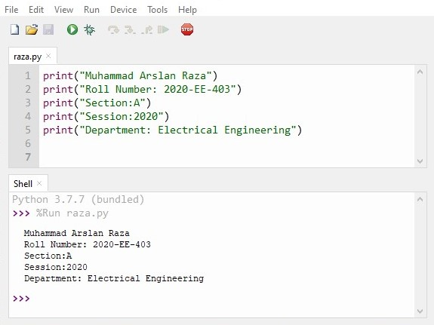

**Conclusion:** Today I learn how to print your name, roll number, section, session and department on output screen

**Task 2:**

Ask user to print two numbers ‘x’ and ‘y’ then print out number ‘x’ raised to power ‘y’.

**Code:**

x=int(input("Enter First Number"))

y=int(input("Enter 2nd Number"))

z=x**y

print("x raised to power y=",z)

**Output:**

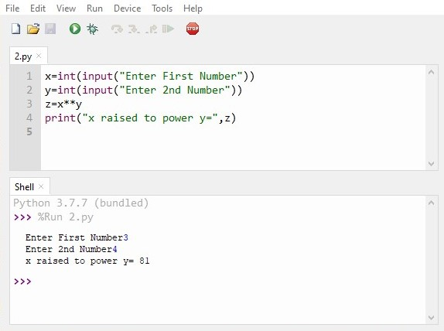

**Conclusion:** Today I learn howto print two numbers ‘x’ and ‘y’ then print out number ‘x’ raised to power ‘y’.

**Task 3:**

Generate two random integers numbers ‘x’ & ‘y’ from users and then print addition, subtraction, division and multiplication of the two numbers. Also observe the output generated by the  
operation x % y.

**Code:**

x=int(input("Enter 1st Number"))

y=int(input("Enter 2nd Number"))

print(x+y)

print(x-y)

print(x/y)

print(x*y)

print(x%y)

**Output:**

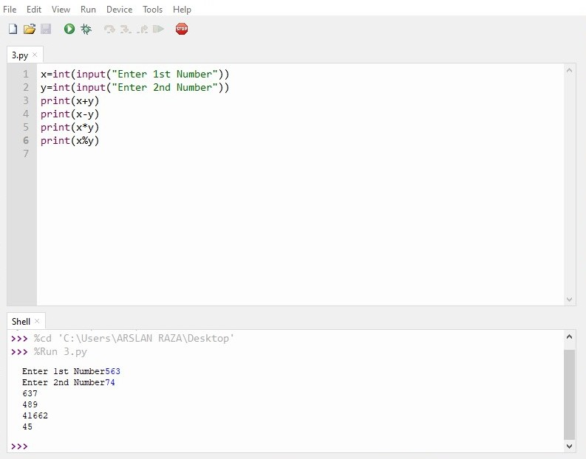

**Conclusion:** Today I learn how to input two integers numbers ‘x’ & ‘y’ from users and then print addition, subtraction, division and multiplication of the two numbers. Also observe the output generated by the operation x % y.

**Task 4:**

Take two variables ‘pi’ and ‘radius’. Assign 3.14 to pi and 4 to radius. Calculate and  
print the area and circumference of the circle.

**Code:**

radius=4

pi=3.14

print("Area of Circle=",pi*radius**2)

print("Circumference of Circle=",2*pi*radius)

**Output:**

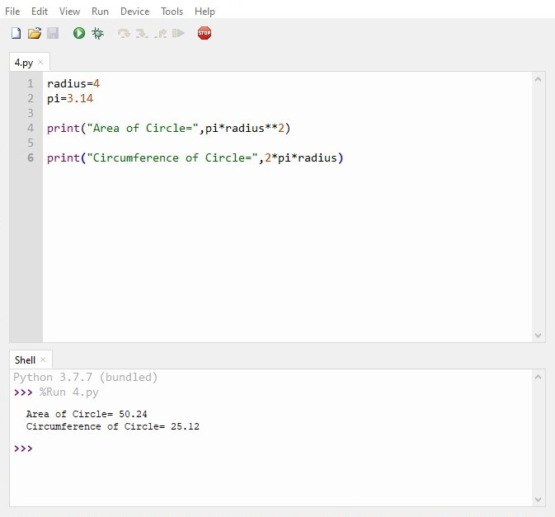

**Conclusion:** Today I learn howcalculate and print the area and circumference of the circle.

**Task 5:**

Take two variables ‘x’ and ‘y’. Save an integer value (e.g. 5) in x and floating value (e.g.  
(5.7) in y. Change the type of integer value to float and floating value to int. Now print  
both numbers and observe the result.

**Code:**

x=5

y=5.7

y=int(x)

x=float(y)

print(x)

print(y)

**Output:**

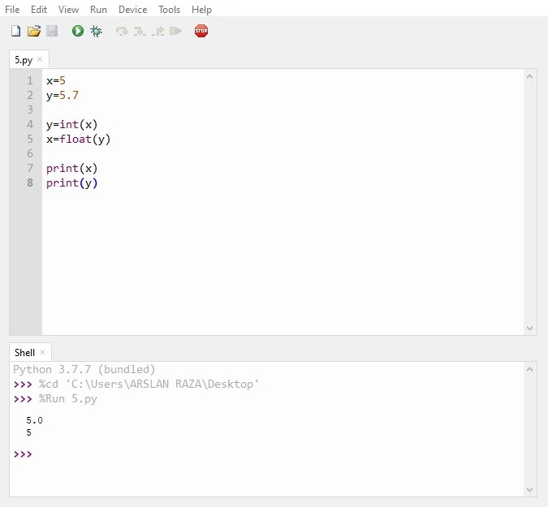

**Conclusion**: Today I learn how to take two variables ‘x’ and ‘y’. Save an integer value (e.g. 5) in x and floating value (e.g. (5.7) in y. Change the type of integer value to float and floating value to int. now print both numbers and observe the result